The House
The House

Doing public art is very demanding since it takes new ways of thinking and approaching the art work and its creation. As an artist you are placed out of your comfort zone but people/public in general is also confronted with your work more than they might usually asked for.
In these particular case the roundabout becomes a very unique space because the viewer is exposed to the work, but at the same time she or he are not allowed to get close, and there vision becomes more like a gaze. The artwork then should be strong, clear and hopefully captivating enough to grasp the attention of such special "passing" public.
Being literally in the "middle of the street" places me and the work in highly peculiar position, somehow ordinary but in every way unexpected. Then by default the "Ordinary" becomes "Extra-ordinary" and that in fact would become the keystone of my project.
The roundabout is now an "Extra- ordinary" place or setting and the street that always leads you home, so known and familiar, has become disturbing and that might carry you to what some people call: Crisis of the proper. Proper since it relates to something personal like names, places, institutions, neigboardhoods, etc...
You can experience a felling of un-canniness for something strange is rising in a commonly known familiar place and there is the "un - homely" taking place at the core of your street. I have been reading about the " Un - canny" and experts say it not only reaches the visual but is also deeply rooted in language and in words of course.
One writer of particular interest to me in the present work is Freud. He takes special attention to the subject and refers to it as: "A place rarely visited by Psychoanalysis". More related, he says, to aesthetics and to the Theory of the Quality of Feelings. He explains that the Un- canny teaches us about foreignness of oneself: The alteration of a small detail on a picture depicts the whole picture strange, it also happens as a reading effect when you re- read differently every time. But is very clear when the difference between imagination and reality is erased. Then art is uncanny and literature and language too. As I said my proposal is based on the above and on the feelings art and words could cause on the viewer.
I would use the shape of a house since almost anybody can identify it as an image of the domestic, the private, and of security. The house would have small alterations in its shape and would have a chimney, windows and doors but would not be possible to enter. The house should be absolutely covered and finished with gray or white marble. On one side of the house the word “Unheimlich" is engraved in the marble and on the other side the word "Heimlich".
I choose the words to be engraved in marble because the material has the power of transforming words into epitaphs giving them a sense of eternity. Also I love the fact of using a stone that is so related to art history and utilized it in a completely new way and with a contemporary meaning.
It is a work that suggests us to put attention not only to the crisis of the proper but also of the natural, directing our attention to our own nature, reality and Art.

Leobendorf Roundabout, Lower Austria

Dibujos 3D/Estudios
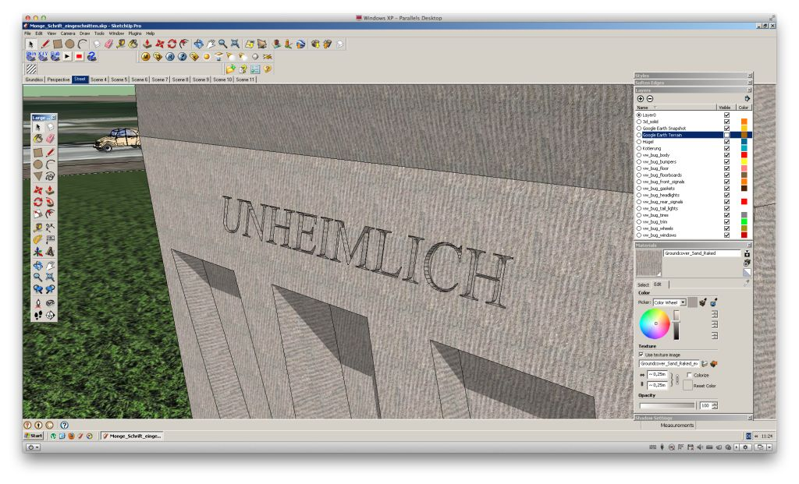

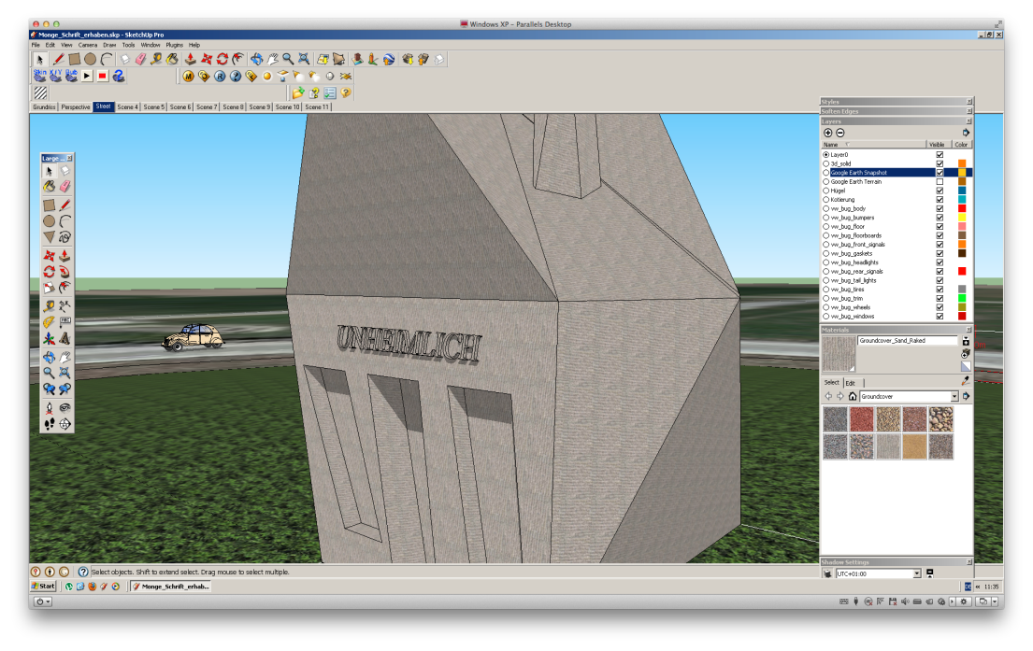

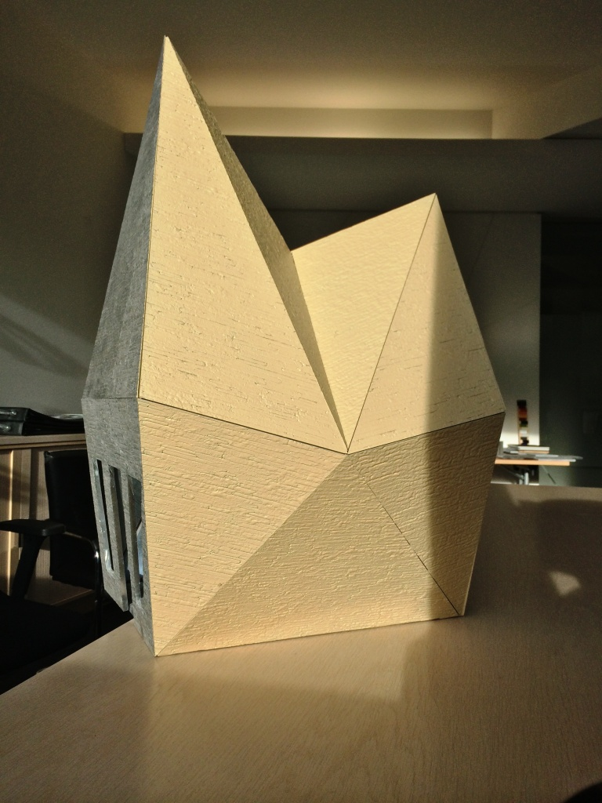

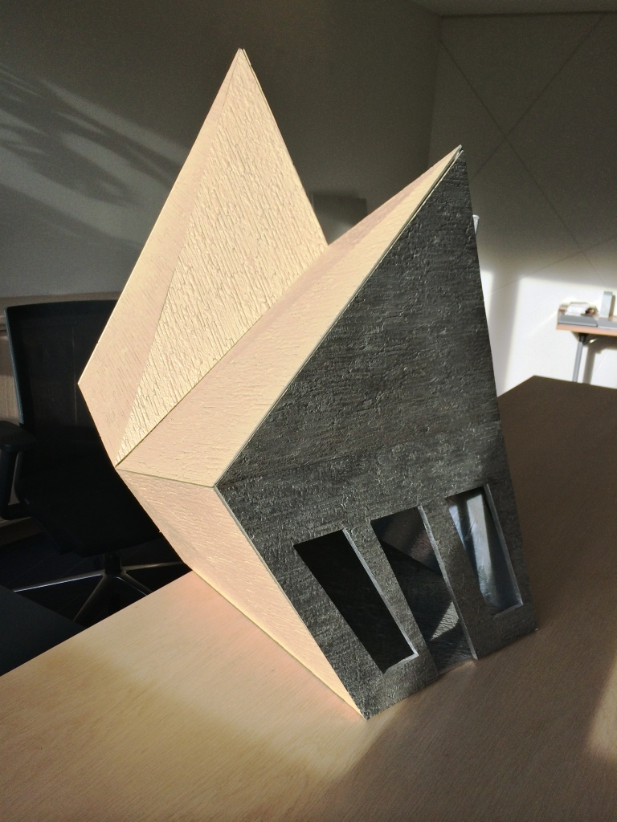

Building Process
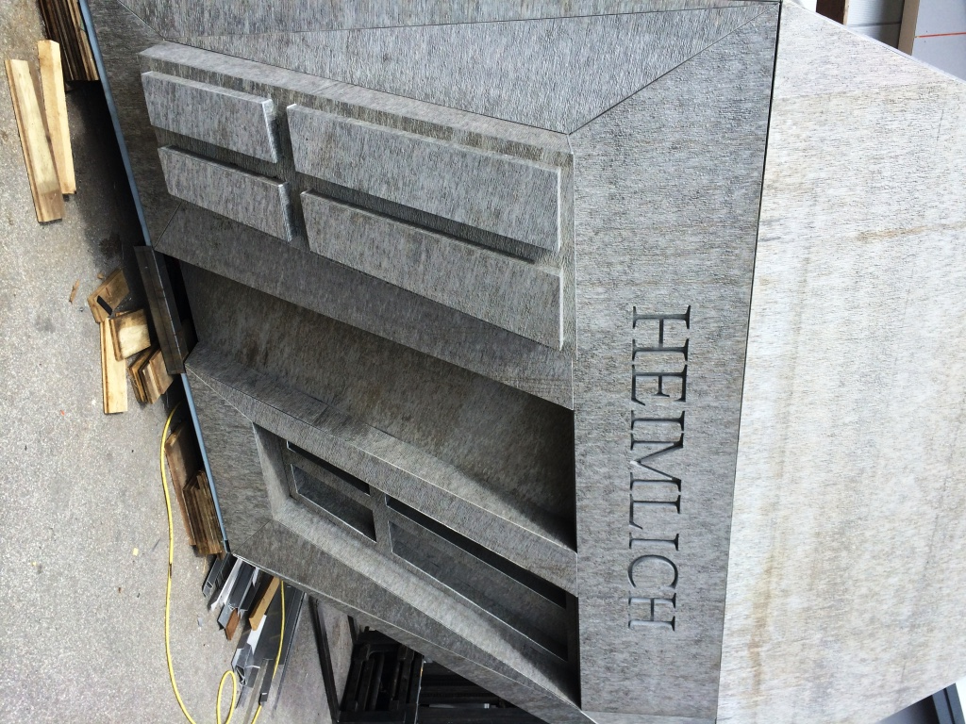

Detail
