Parásitos Urbanos
The Urban Parasites project emerge from complex restructurings of technological waste, electronics and mechanical systems that are configured as artificial living organisms with the ability to survive in urban environments. Many of these parasites feed on the energy they steal from the power distribution network of cities and interact with their environment by moving into its territory. Some of the species make sounds to communicate with other parasites of its species as part of the urban soundscape.

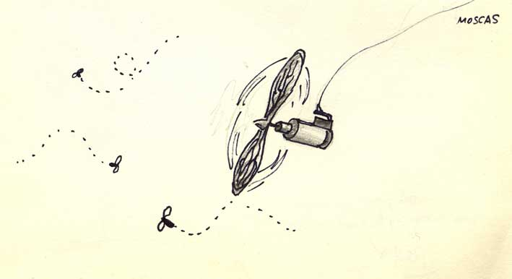
Mosca. Cellphone motor, copper wire and controller
Elíptero embobinado. The fly consists of a diminute motor with propeller hanging from a filament. The motor is extracted from mobile cellphones. The fly flies in enclosed areas and has a territorial behavior.

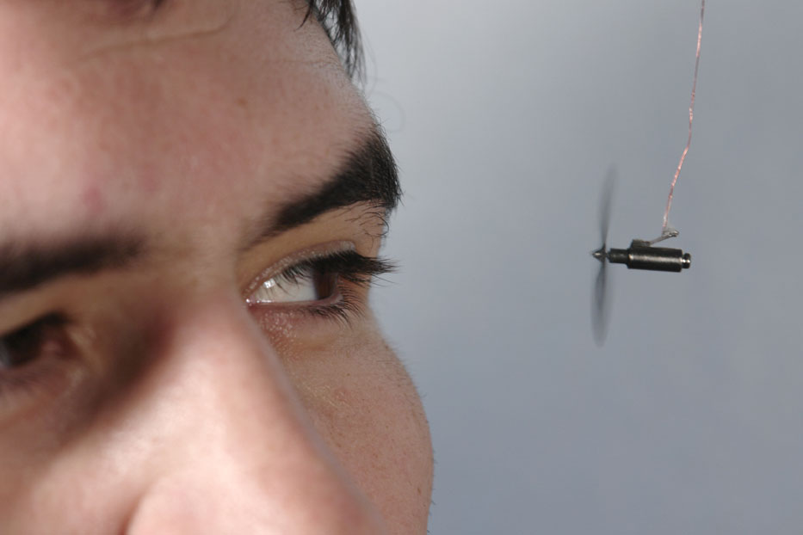

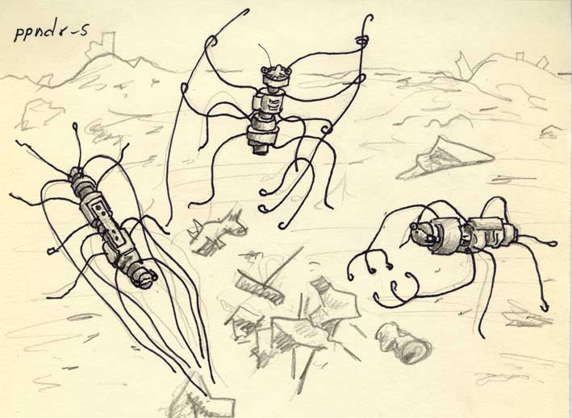

Ppndr-s Motors from toys, wire, technological waste
Alambrópodo iocus-obsoleto. Commonly inhabit-waste piles accumulating in some parts of the city. They are able to perform tasks such as garbage removal and spreading.
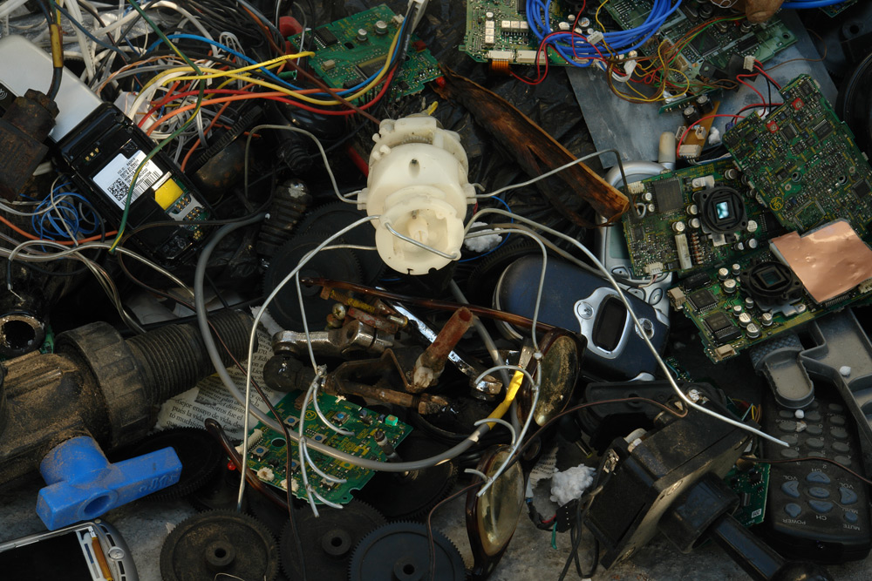

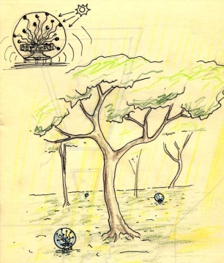
Autótrofos inorgánicos. Acrylic spheres with electronic circuits extracted from hacked toys.
Are organisms that use sunlight and translating it into electrical noise.
Outdoors, these organisms are sensitive to light variations caused by the shadows of the trees during the day. These variations are processed and translated into sounds that involved the soundscape of their environment.
These organisms have circuits from toys and musical devices that were modified to operate in a range of variability, to interpret random values ​​in light conditions.

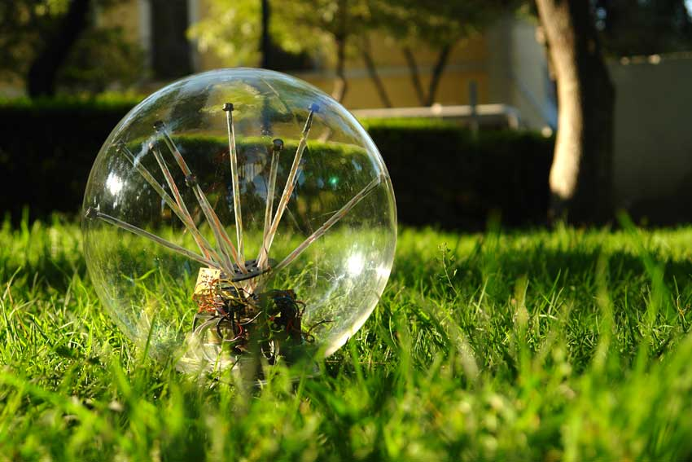

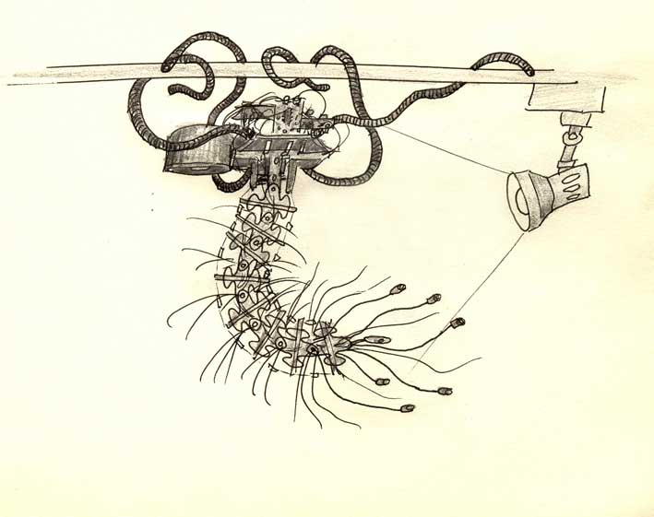

Mrñ. Motor, nylon, acrylic, computer speakers and microcontroller
Helminto enmarañado. Its body is formed by segments of wires and acrylic. He lives near light sources that used for make sounds. It feeds on the same outlet that manages the source of light.

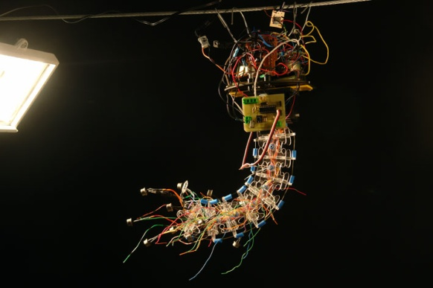

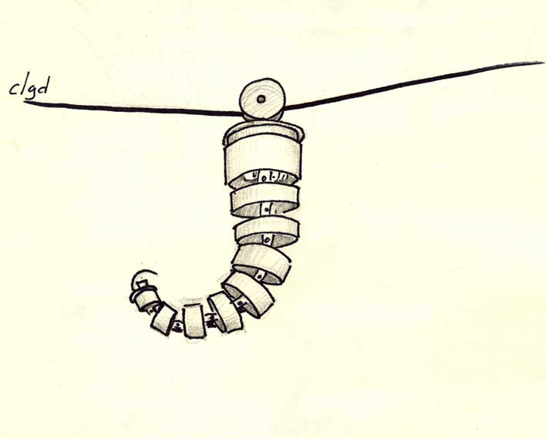
Clgd. motors, pieces of PVC tube, aluminum micro-controllers, sensors
Helminto poleápodo. Its body is formed by a set of leftover PVC tubes which are articulated with each other.
This parasite lives hanging in the telephone wiring and beeps to interact with the surrounding sound environment. It feeds on the energy of the city power lines.

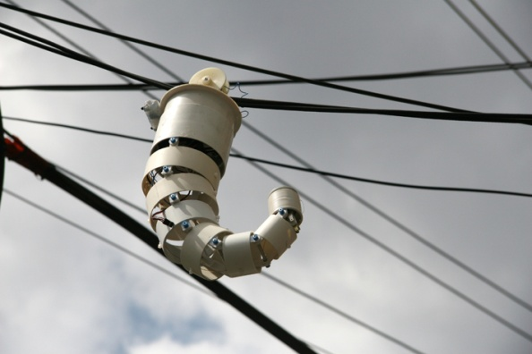

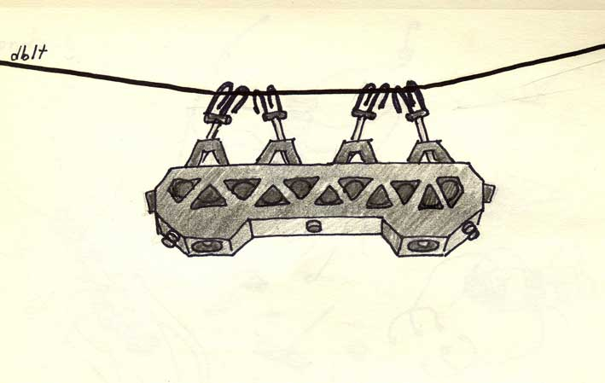
Dblt. Motor and recycled parts, actuator, acrylic, aluminum, microprocessors, sensors
Mecatrópodo engranado. It inhabits in the city power lines and steals the energy for survival. This species stores surrounding sounds and plays intermittently according to their mood.

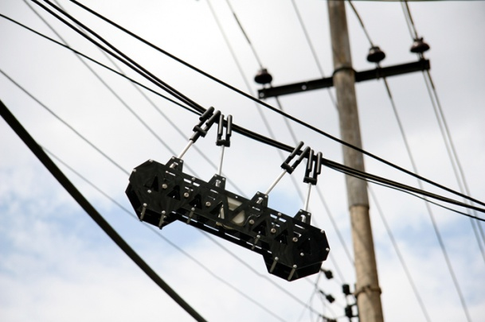

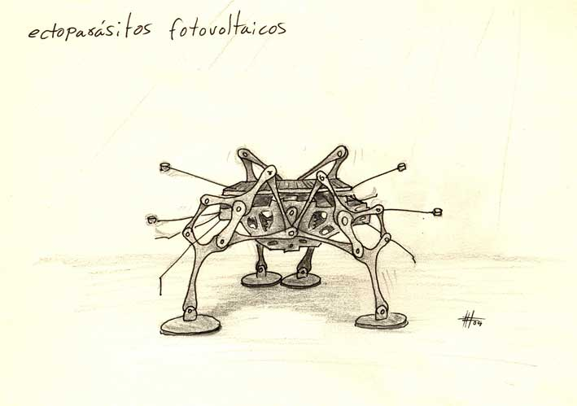
Ectoparásito fotovoltaico. Motors, acrylic, solar cells
This species feeds on sunlight and live in the roofs of buildings, glass skylights or domes in which emits sounds through vibrations to try to communicate with others of their species.

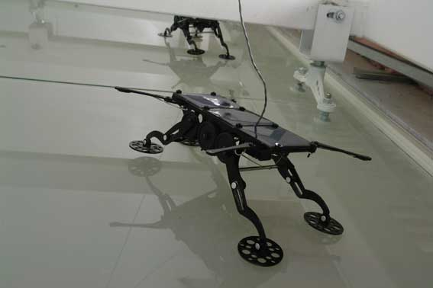

Credits:
Support Program for Production and Research in Media Art 2006, Centro Multimedia, Centro Nacional de las Artes, Mexico
Prize INCENTIVOS A LA PRODUCCIÓN IBEROAMERICANA, VIDA 9.0, 2006 by Telefonica Foundation.
Colaboration: Julio Zaldívar, Miriam Beutelspacher, Marcela Armas, Iván Puig, Ariel Guzik, Javier Álvarez, Blanca Cuevas, Nadia Leal, Maddalen Aguirre.

