RESIDENCY
A L T O is now inviting artists to submit applications for vacancies at the residency commencing November 2013.
The opportunity exists for artists from all around the globe within all practices to take a residency at A L T O. This can be privately-funded, funded by a third party interested in promoting an individual’s work, or by grants, scholarships etc.
As a resident artist you will have the possibility of working within 40 hectares of lush jungle by the most amazing cliffs. The residency can take place for periods of 2 weeks to 3 months.
Artists will have full use of a studio and the use of the shared circular studio. There are a series of extra comforts for good health and living including a Finnish sauna, large rock mineral water pool fed by a beautiful John Wilkes flowform. There are unique sleeping rooms at Mariri Jungle Lodge to choose from:
A 10m Tower Room, the Bamboo Chalet, the Tree House or the more traditional Orange and Stone Rooms.
Resident artists will be featured on the A L T O web page, which will include biographical information and images of work produced during the residency.
Group residencies
We can also host group residencies for groups belonging to an institution, or art group/collective.

How to get to Alto Paraiso
- By Plane to Brasilia
Most air travelers arrive at the Brasilia airport. There is a small domestic airport in Alto Paraiso, for small planes, but there are no regular air services.
- then continue by:
Bus
The companies that make the route Brasilia-Alto Paraiso are Real Expresso and Santo Antônio. There are two bus stations in town make sure you research this before.
Driving
- From Brasilia take the BR-020 toward Salvador (for those arriving by plane: Airport> South Eixão> North Eixão> Bragueto Bridge> Torto Roundabout> Posto Colorado> Sobradinho) and turn left into the BR-010 (GO-118) after Planaltina (the roundabout is well signposted). Total distance from Brasilia is 230 km.
- From Goiania, pass Brasilia and follow the above route.
- From Sao Paulo, take Via Anhanguera (SP-330) until Uberaba. From there, take the BR-050 to Brasilia.
Taxi
We can arrange a shared taxi lift from Brasilia airport to central Alto Paraiso for 60R$ or if you would rather book the entire car for yourself the cost is 200R$ for the 230km ride.
Let us know in advance if you want us to book this for you.
From Town to the residency
We will come to pick you up with a car for 50R$ or you can get a moto taxi for 20R$. Please be aware it is a very bumpy road.

Who we are

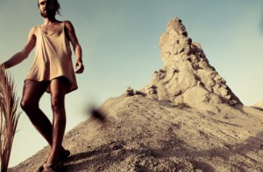
Rafael Perez Evans
Founder of A L T O Arts Residential Project.
Half Spanish – Welsh Artist, Rafael studied a BA in fine Arts at Goldsmiths University London. Works with photography, moving image & dance. He has set up and managed art spaces in London, USA & Mexico.
Has an active interest in Photography, Arts management and Nature. He now continues his practice at
A L T O.
http://www.rafaelperezevans.com
__________________________________________________________________________
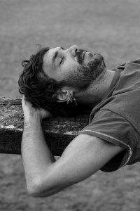
Jaime Brough
Founder of A L T O Arts Residential Project.
Born in Argentina, Jaime studied sculpture at Camberwell University in London. Lately working with collage, painting and installation. Jaime is cultured in natural architecture and permaculture.
______________________________________________________________________________________________________________________
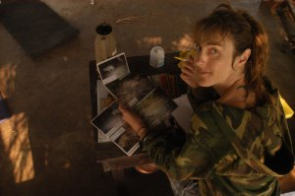
Marianne Soisalo
Founder of A L T O Arts residency Project.
MSc in Zoology at University of Cambridge. Big cat scientist, environmental activist & graphic designer (www.ekonoiz.com), permaculturist, creative, seeker.
Built Mariri Jungle Lodge, African-style home/healing retreat & permaculture centre in the jungle.
Founder of Eco Nois the local Eco-cultural hub where she has called for a collective movement to join forces in various transition projects related to a more sustainable future for the region.
Main projects in town include a community cafe’, permacultural urban garden with examples of bio-construction and a community Arts Project that raises awareness about the man-made fires that yearly wipe out flora and fauna (www.chegadefogonachapada.blogspot.com).
Blog at WordPress.com. | The Imbalance 2 Theme.

